Write-up for Allstate

Business Analyst, Allstate Financial Group
Allstate Corporation, Northbrook, IL Nov 2002 - Feb 2004

The Allstate Corporation is the nation’s largest publicly held personal lines insurer. Allstate Financial Group is a division of Allstate Corporation that encompasses the businesses that provide life insurance, annuity, and retirement products. This project involved creating and enhancing accessAllstate.com, a web-based policy management system, which integrated Allstate’s several policy management systems and extended the functionality to provide anywhere, anytime access to information to Allstate’s countrywide network of sales representatives and independent agents.

Environment: Microsoft’s Visual Studio .NET, Microsoft SharePoint, XML, Web Services Technologies, Java 2 Platform, SQL, Rational Rose, Rational ClearQuest

Responsibilities:

- Assisted with detailed project planning by contributing and creating project definition documents, business requirements documents (BRD), and functional requirements documents (FSD)
- Organized and led design review sessions for all the complex business/functional requirements and issues resolution
- Contributed to detailed deliverables and obtained requirements documents and functional designs sign-off
- Identified testable business requirements and functional test conditions for new platform
- Proposed and designed Extensible Markup Language (XML) data transfer between the host servers and agents; tested the data transfer for high traffic
- Designed the Microsoft .Net Framework together with J2EE web services platform for interoperation
- Performed activity based cost-benefit analysis and return on investment (ROI) and net present value (NPV) calculations
- Used Rational ClearQuest for all types of change requests, including defects, enhancements, issues and documentation changes with a flexible workflow process
- Prepared and reviewed training and user documentation about the new system

My Role:

I worked at Allstate for a period of 16 months from Nov 2002 to Feb 2004.

I worked with the Allstate Financial Group which provides life insurance, supplemental accident and health insurance, annuity, banking and retirement products designed for individual, institutional and worksite customers.
(Allstate also provides home insurance and auto insurance through a separate subsidiary.)

These products are distributed through Allstate agencies, exclusive sales representatives, or nonexclusive producers (independent agencies, financial institutions and broker-dealers). These independent producers had no direct access to the data in Allstate’s policy management systems. Instead, they were forced to call the Allstate service center and speak with a representative to perform common tasks such as tracking the status of a new life insurance policy through the underwriting process. Similarly, all account transactions—even a simple address change—had to be made by mail, fax, or a call into Allstate’s service center.

This project concentrated on accessAllstate.com – an application that gives financial professionals access to the company’s five policy (multiple information) management systems through a Web portal. The representatives can access policy and product information online, download forms and documents, and manage their clients’ accounts – all tasks that previously required telephone conversations through an Allstate call center.

Earlier, all the policy and account information resided on five policy management systems running on mainframe computers – substantial technology investments that Allstate was not willing to toss aside. But because Web services enabled communication between any applications or systems, Allstate didn't have to.

Allstate mainly used the .NET Framework and Visual Studio .NET to create AccessAllstate.com. It used Windows 2000 Server, SQL Server 2000 and BizTalk Server 2002 to harness the power of extensible markup language Web services along with other technologies, including Java 2 Platform, Enterprise Edition connectors.

With the Web portal on the front end and five host systems in the back, Web services navigated the middle ground. A pair of servers performed integration, communicating with the Allstate host systems and creating XML (eXtensible Markup Language) data that could be transferred to agents.

Groups of application servers and Web servers then negotiated between Allstate's computers and agents in much the same way that traditional Web sites operate.

So why Microsoft .NET and not one of the other Web services platforms like IBM WebSphere, which is based on .NET nemesis Java 2 Enterprise Edition (J2EE)? In fact, Allstate does use J2EE as well. Fortunately, with some programming handiwork, the two standards are interoperable via Web services.

(For more technical information: Allstate Case Study - Online Management System - useful.doc)

This application resulted in decreasing operating (call center and mailing) costs and increasing revenues. It later became a reusable resource across departmental lines at Allstate. With a few minor tweaks, the same project was recreated for Allstate.com customer care center.

Fast Facts
Number of developers to build application | 45
Number of months to build application | 7
Cost | $13 million
Number of registered users (as of 2005) | 14,000
Size of database | 50 GB
Performance improvement over ASP | 200–300%

BA Responsibilities:

- Primary liaison between the Allstate Financial Group and the Allstate Technology Operations – Global Talent Pool
- Providing business knowledge to the IT team
- Conducted training workshops for different batches of users, documented training manual, and FAQ for accessAllstate.com
- Contributed to the Project Charter, BRD, and FSD. Made plenty of Use Cases and Activity Diagrams. Used Rational Rose and MS Office Suite.
- Got sign offs and budget approvals on all documents
- Conducted cost benefit analysis for the new application
- Used Rational ClearQuest for all types of change requests, including defects, enhancements, issues and documentation changes
- Internal Consulting – Skilled at interacting directly with clients from problem definition through implementation—demonstrated ability to bridge the gap between the business and consulting tasks.
- Facilitation – facilitated meetings and processes where the subject was moderately complex.

What do I know about XML?

The Extensible Markup Language (XML) is a general-purpose specification for creating custom markup languages. It is classified as an extensible language, because it allows the user to define the mark-up elements. XML's purpose is to aid information systems in sharing structured data, especially via the Internet.

An XML document has two correctness levels:

- Well-formed: A well-formed document conforms to the XML syntax rules; e.g. if a start-tag (< >) appears without a corresponding end-tag (</>), it is not well-formed. A document not well-formed is not in XML; a conforming parser is disallowed from processing it.
- Valid: A valid document additionally conforms to semantic rules, either user-defined or in an XML schema, especially DTD (Document Type Definition); e.g. if a document contains an undefined element, then it is not valid; a validating parser is disallowed from processing it.

What do I know about Web Services?

A Web Service is defined as "a software system designed to support interoperable machine-to-machine interaction over a network". Web services are frequently just Web APIs (Application programming interface) that can be accessed over a network, such as the Internet, and executed on a remote system hosting the requested services. Web services use XML messages to transfer data.

What do I know about .NET?

The Microsoft .NET Framework is an integral Windows component that supports building and running the next generation of applications and XML Web services.

Microsoft Visual Studio .NET is the rapid application development (RAD) tool for building next-generation Web applications and XML Web services. Visual Studio .NET empowers developers to rapidly design broad-reach Web applications for any device and any platform. In addition, Visual Studio .NET is fully integrated with the .NET Framework, providing support for multiple programming languages and automatically handling many common programming tasks.

Although .NET apps can interoperate without the help of Web services, .NET components can communicate with non-.NET applications (like Java apps) via Web services.

Corporate Headquarters:

2775 Sanders Road
Northbrook, IL 60062
847-402-5000

www.allstate.com

Social Life:

Places to lunch/eat close by:

Fast food such as McDonalds, Burger King, and Subway were all close by. Then there was a Denny’s and some other local cafes too which served decent food. All these were on Milwaukee Ave (1.5 miles – 20 minutes by walk).

Hotels close by:

Radisson, Hilton, Wyndham, Courtyard, Super 8, etc. – lots of budget and fancy hotels on Milwaukee Ave. (just parallel or you can say v-shaped to Sanders Dr.)

Stay:

First 2 weeks I stayed at an Extended Stay (on Capital Dr., 2 miles away), then I moved into an apt called River West Apts (1510 N River West CT, Mount Prospect, IL‎ - (847) 824-1090‎). This place was conveniently located and I saved time travelling.

Distance from Chicago:

It took about 45mins-1hr to get to Chicago Downtown, depending on traffic. (Roughly 25 miles) I was relatively free on weekends, so I ended up going to the Downtown a lot. Directions to get back – head onto I-90 W (15 miles) and then take I-294 N (6 miles).

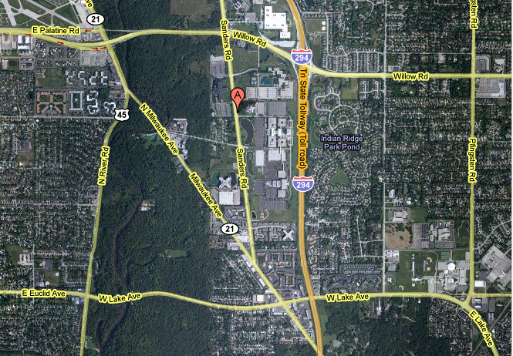

Useful Links:

http://www.accessmylibrary.com/coms2/summary_0286-22709089_ITM

http://www.pcmag.com/article2/0,2817,905592,00.asp

